Rice Phenological Monitoring 2016

Lorenzo Busetto - CNR-IREA - Milano

14 July 2016

## Results of Phenological Mapping - ERMES project

This document show results of rice phenological mapping conducted within the ERMES project for the ES study area. Sowing dates were estimated starting from time series of MODIS 250m resolution imagery, using the PhenoRice algorithm.

## Raster Maps

Raster data - aggregated on 2x2 Km regular grid

### 2011-2016 Sowing dates maps

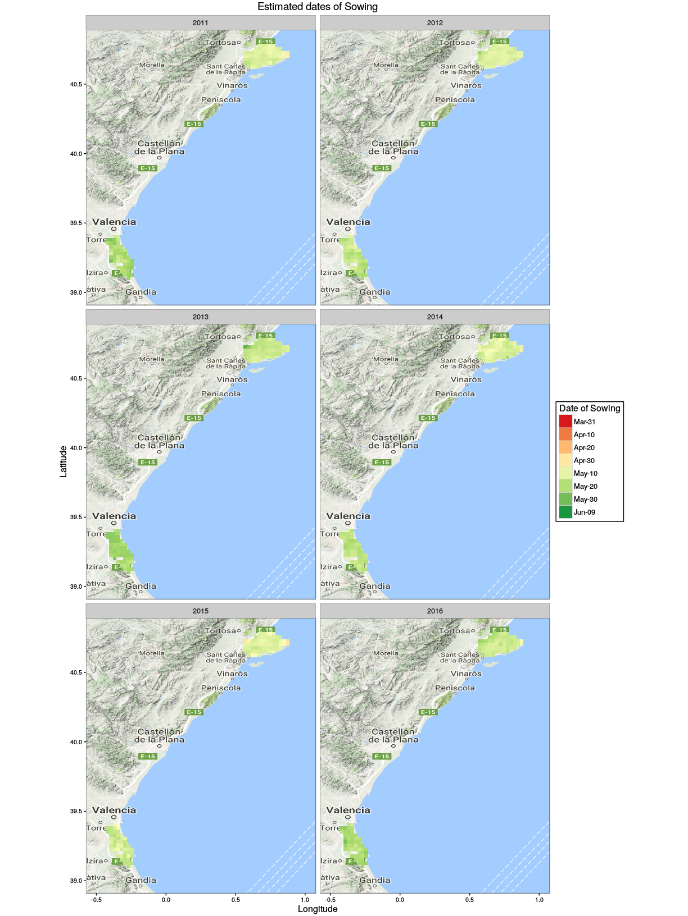

### 2016 Sowing dates map

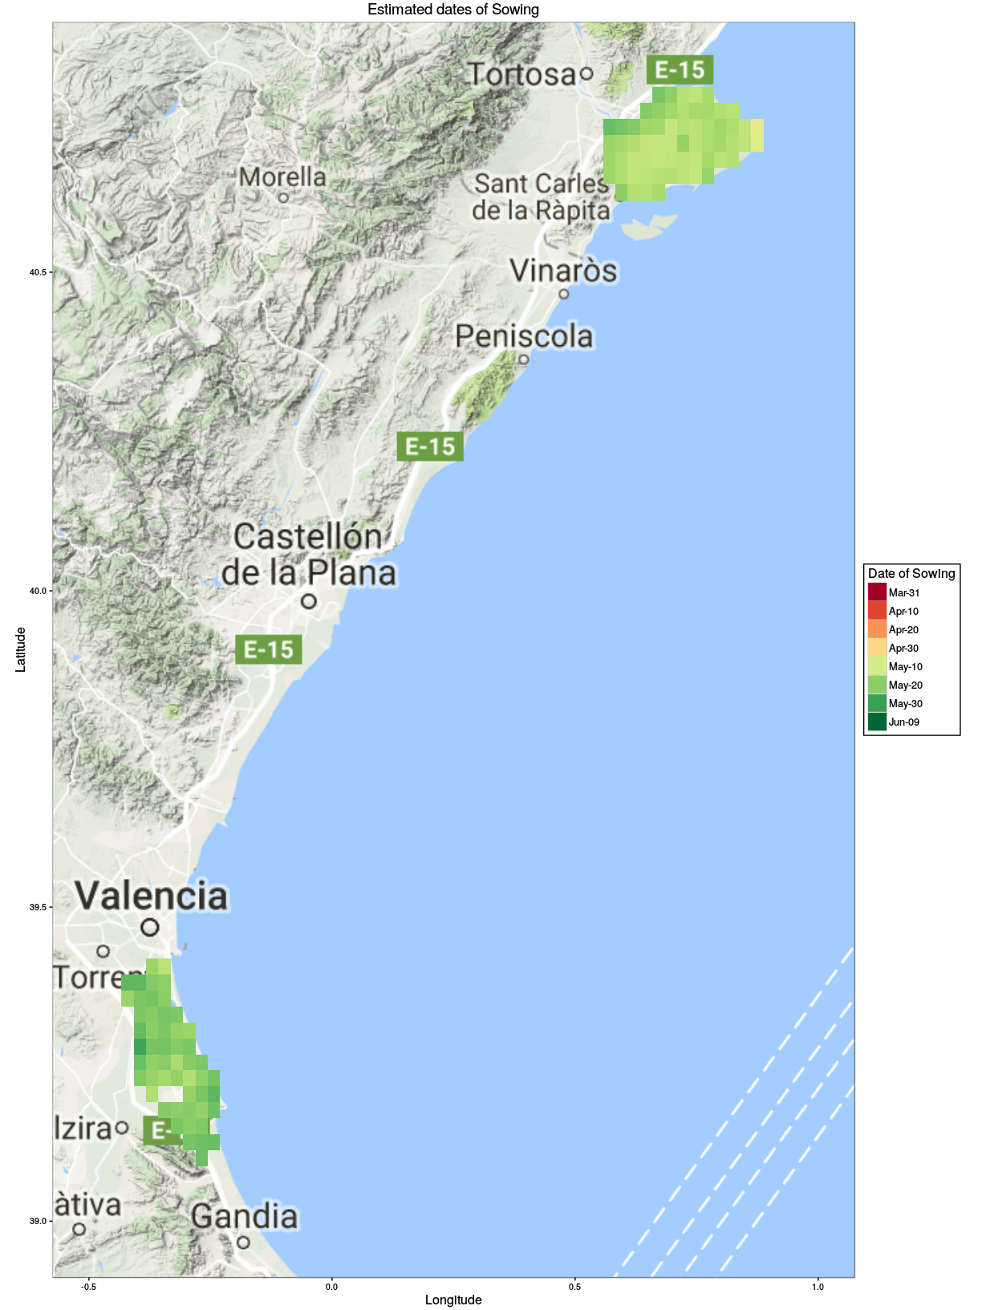

### 2003-2016 Sowing dates anomalies with respect to average

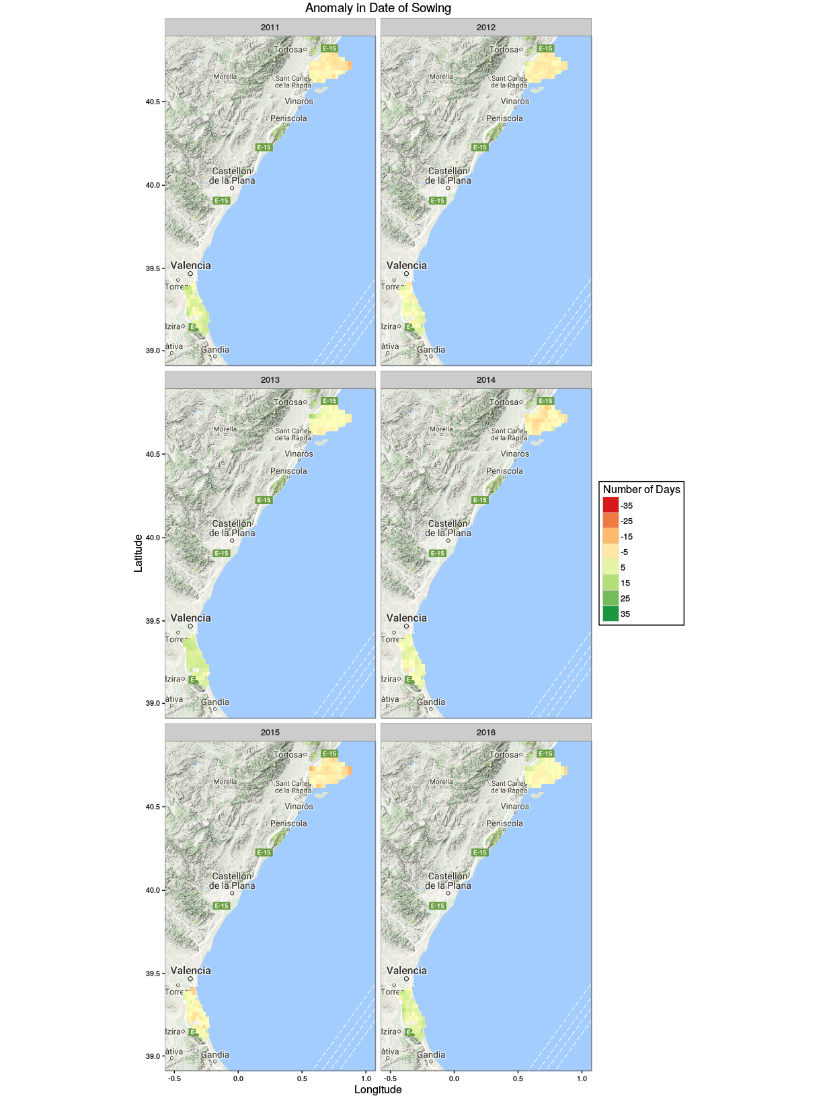

### 2016 Sowing dates anomalies with respect to average

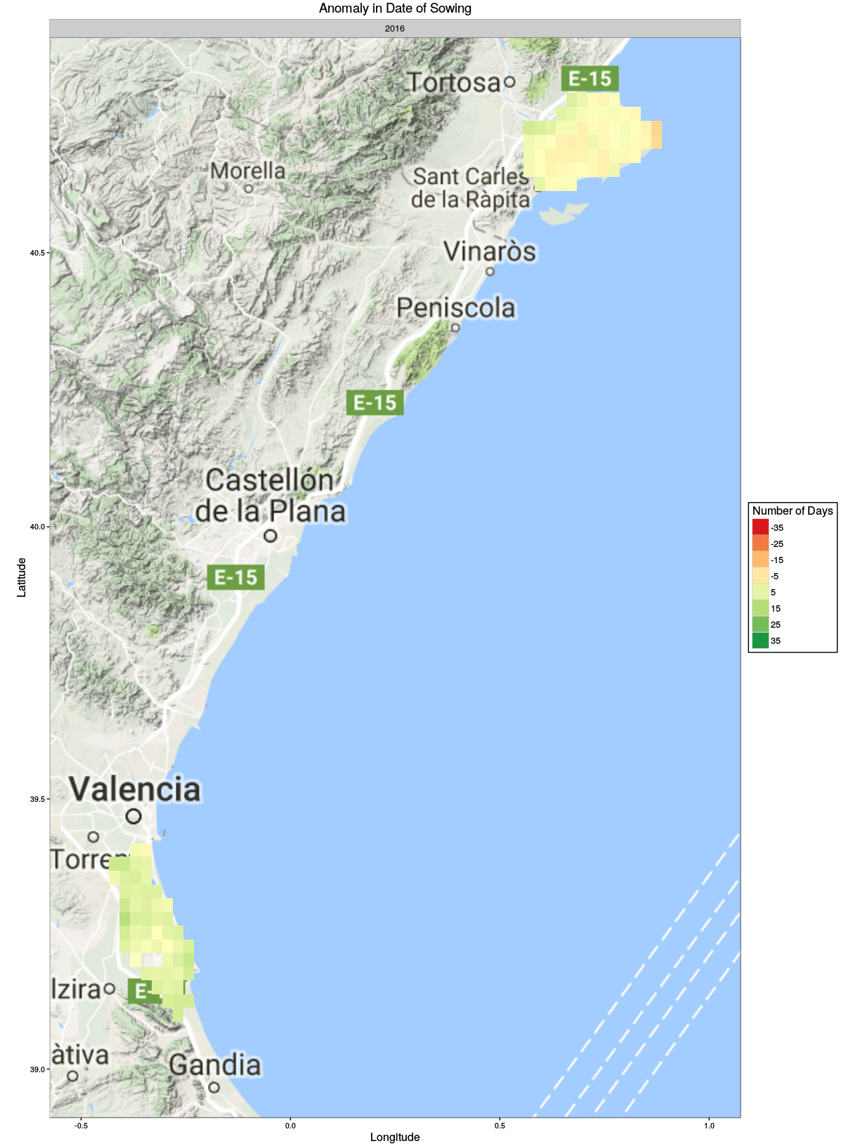

## Data aggregated on Municipalities

The following maps show results similar to the previous ones, but aggregated on administrative units.

### 2003-2016 Sowing dates maps, on municipalities

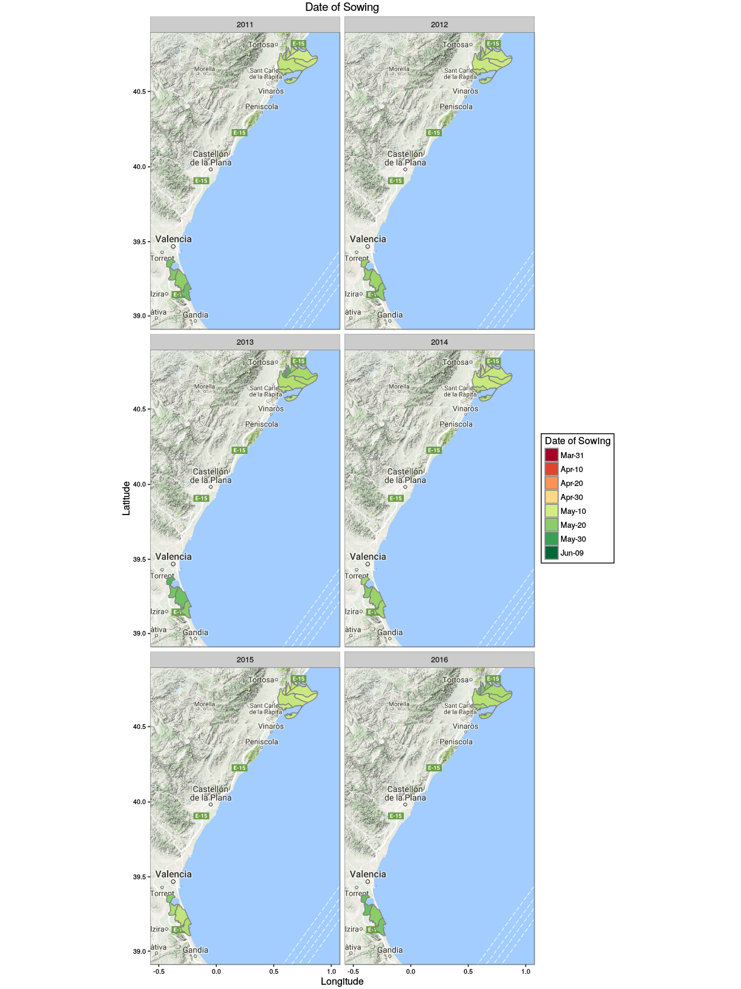

### 2016 Sowing dates map, on municipalities

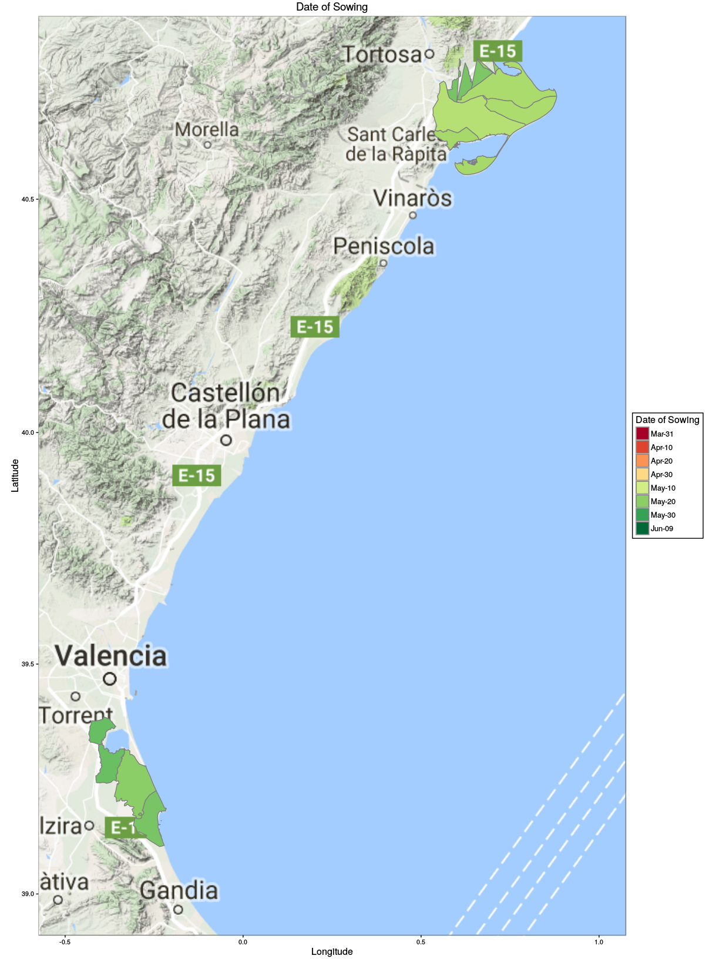

### 2003-2016 Sowing dates anomalies with respect to average, on municipalities

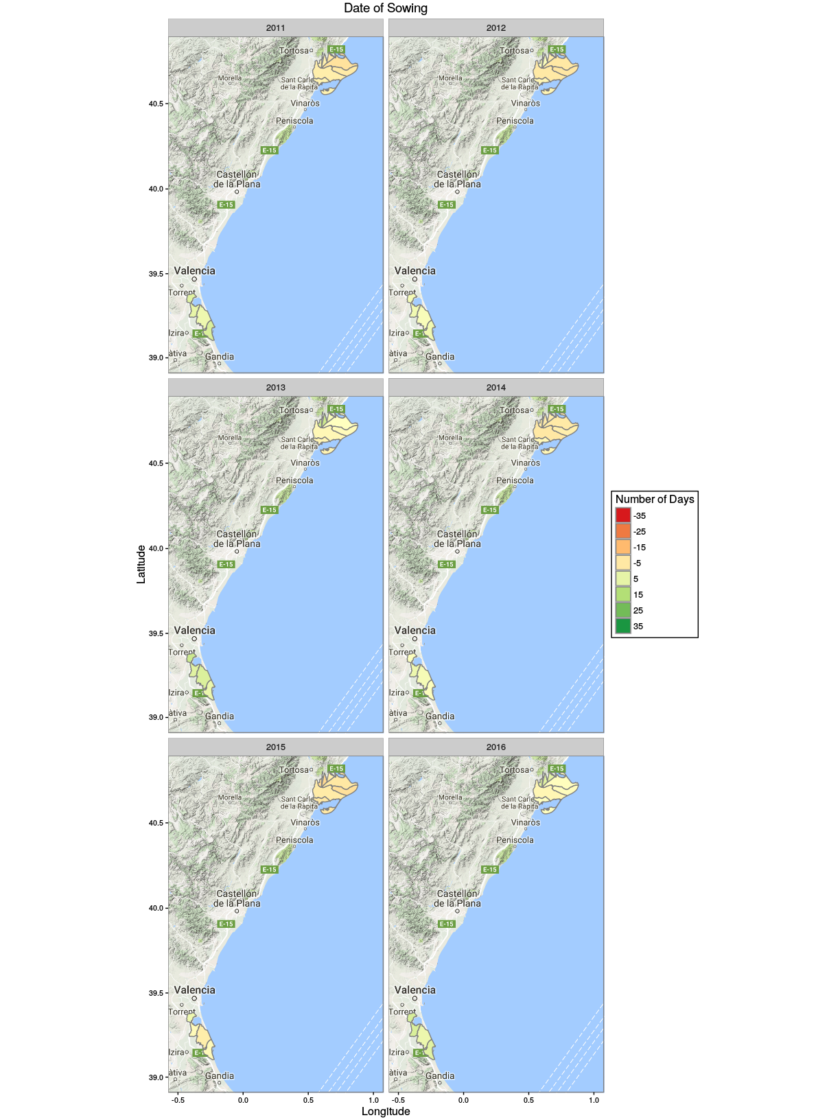

### 2016 Sowing dates anomalies with respect to average, on municipalities

